Practical – 19

Code Block : To print different patterns

Question- 19 (i)

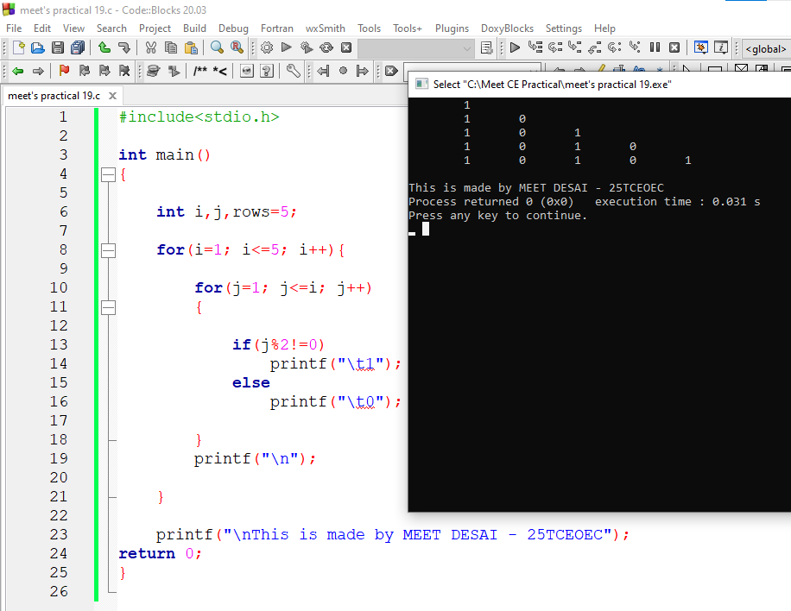

Question- 19 (ii)

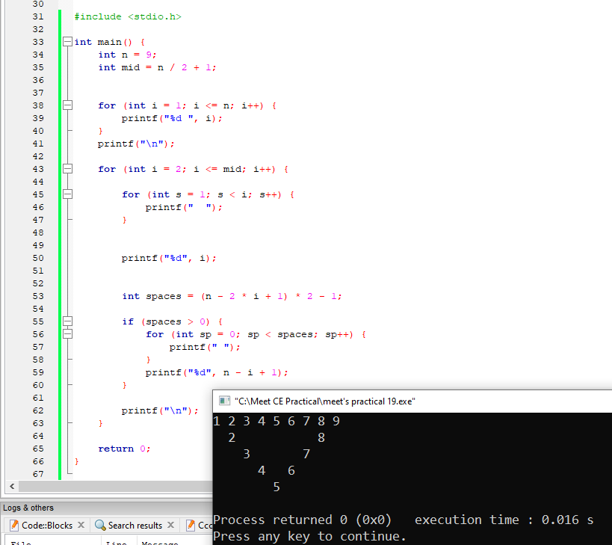

Question- 19 (iii)

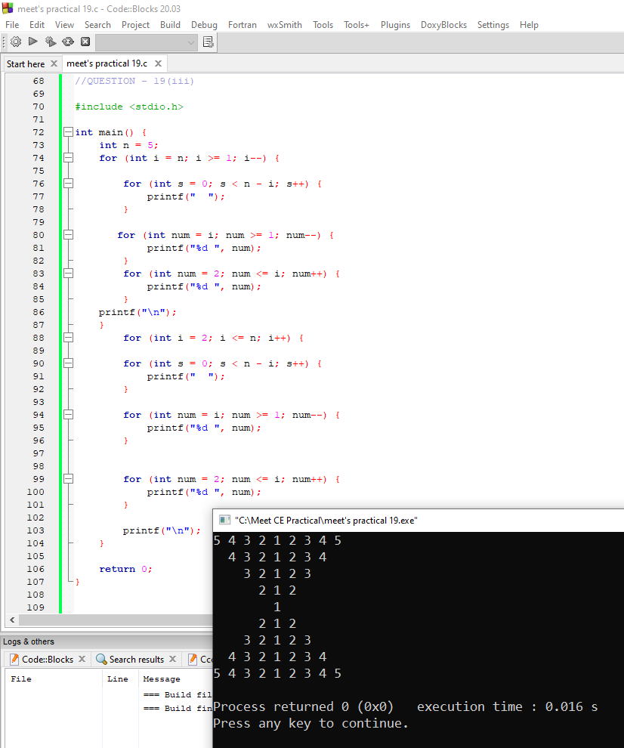

Question- 19 (iv)

